OpenESP
Admin Guide

Innholdsliste
Introduction 3
What is OpenESP 3
Document version 3
OpenESP components 3
Tomcat 3
Solr 4
ManifoldCF 4
ZooKeeper 4
Other tools 4
Versions and release notes 5
System requirements 5
Hardware requirements 5
Operating System requirements 5
Browser requirements 6
Java requirements 6
License 6
Support & training 6
Installation 6
Prerequisites 6
General installation notes 7
Memory allocation 7
Installing using the installer 7
Manual installation 13
Configuration 13
General 13
Ports 13
Enable or disable apps 14
Windows service startup options 14
Securing the search server 14
Solr 14
ManifoldCF 15
Monitoring 15
Search Analytics 16

Introduction

What is OpenESP
OpenESP is an Open Enterprise Search Platform, built on the foundation of Apache™ Solr™, Apache Tomcat™, Apache ManifoldCF™ and and other state of the art open source products. The goal is to help users getting quickly up to speed without the need to understand each single piece of technology in-depth. OpenESP has many best-practices and configurations built right in from the start.
To get involved in the project, head over to https://github.com/openesp/openesp

Document version
This document relates to OpenESP version 0.4, released 2013-XX-XX. Please visit the project website to look for older or newer versions.

OpenESP components
The product consists of the following parts:
- Apache Tomcat servlet container
- Apache Solr enterprise search server
- Apache ManifoldCF connector and security framework
- Apache ZooKeeper (standalone)
- Vifun request parameter tuning tool
- SolrMeter benchmarking tool
- Prepared for Sematext SPM and Search Analytics SaaS
- An OpenESP administration panel for a full platform overview
- Windows installer (IzPack based)

Tomcat
Apache Tomcat (tomcat.apache.org) is an open source web server and servlet container developed by the Apache Software Foundation (ASF). Tomcat implements the Java Servlet specification, required for running Apache Solr.

Solr
Apache Solr (lucene.apache.org/solr) is an open source enterprise search engine. It is the most deployed search engine in the world. Its major features include powerful full-text search, hit highlighting, faceted search, near-real-time search, database integration, and rich document (e.g., Word, PDF) handling. With SolrCloud it easily scales to hundreds of servers, providing full fault tolerance for both search and indexing, with distributed search/indexing, leader election and recovery on failures etc.

ManifoldCF
Apache ManifoldCF (manifoldcf.apache.org) is aproduct which provides an open source framework for connecting source content repositories like Web sites, File systems, Microsoft Sharepoint or EMC Documentum, to target repositories or indexes, such as Apache Solr. ManifoldCF also defines a security model for target repositories that permits them to enforce source-repository security policies. The framework is pluggable, so support for new repositories can be added in a matter of hours or days.

ZooKeeper
Apache ZooKeeper (zookeeper.apache.org) is a centralized service for maintaining configuration information, naming, providing distributed synchronization, and providing group services. It is a key requirement for reliably running a SolrCloud cluster. Although Solr can be started with an in-process ZooKeeper, it is recommended to use a standalone cluster of 1, 3 or 5 ZooKeeper nodes.

Other tools
There are many useful 3rd party tools related to Solr. OpenESP bundles a few of these:
Vifun (github.com/jmlucjav/vifun) was developed in order to help tweak the values of boosting functions etc in Solr, typically when using edismax handler.
SolrMeter (code.google.com/p/solrmeter/) is a "generic tool to interact specifically with Solr", firing queries and adding documents to make sure that your Solr implementation will support the real use. With SolrMeter you can simulate your work load over solr index and retrieve statistics graphically.
Sematext SPM (sematext.com/spm/) is a performance monitoring solution available in the Cloud (SaaS) as well as on Premises. Track key operational metrics with a graphical dashboard. We've made it super easy to enable SPM with OpenESP.
Sematext Search Analytics (sematext.com/search-analytics/) is a cloud-based Search Analytics service. It lets you view up-to-the-minute Search Analytics graphs, charts, and tabular data, spot trends, slice and dice data by time, by query origin or type, and other dimensions. Get started in record time with the pre-integrated search GUI.

Versions and release notes
This table lists the versions used and a link to release notes for each component. Please read each of these documents to know about important changes from previous version as well as known bugs and limitations.
Component | Version | Release notes/errata
OpenESP | 0.4 | https://github.com/openesp/openesp/wiki/Release-notes
Tomcat | 7.0.42 | http://tomcat.apache.org/tomcat-7.0-doc/changelog.html
Solr | 4.4 | http://lucene.apache.org/solr/4_4_0/
ManifoldCF | 1.3 | http://manifoldcf.apache.org/en_US/release-documentation.html
ZooKeeper | 3.4.5 | http://zookeeper.apache.org/releases.html#releasenotes
SolrMeter | 0.3 | https://code.google.com/p/solrmeter/wiki/about

System requirements

Hardware requirements
OpenESP runs well both in dedicated and virtualized environments. It can run on your laptop with 100Mb, but here we list adviced mimimum spec for a small-scale production system. Observe that a search server may require extreme performance, so if you rely on shared resources you may not be able to predict the actual performance. In such cases be sure to run on dedicated hardware with dedicated I/O bandwidth.
CPU: Modern, multi-core CPU (64-bit highly recommended, but it will install on 32-bit as well)
RAM: Most search systems will benefit greatly from having 8 Gb or more physical memory, as fitting the whole (or most) of the index in RAM speeds up your search server many-fold.
DISK: For systems with an index size much larger than physical memory, disk performance may be critical, and require high performance disk system, such as multiple 15kRPM+ disks in RAID setup. Alternatively consider SSD. For many systems, the majority of the index fits in RAM and disk thus becomes less important.
Warning: Do not put the index on NFS mounted shared disk. The performance is terrible and it will not work without extensive tweaking.
Final hardware requirements depends on the intended data and query volume. Contact a search specialist for tuning systems with multi-million documents.

Operating System requirements
OpenESP is based on Java technology, and thus in theory runs on any platform, including Linux, Windows and OSX.

Browser requirements
The Administration GUI of Solr uses new standards-based AJAX technology and thus requires a standards-compliant browser. Current versions of any browser should do. Note that if you use Internet Explorer, then at least version 9 is required.

Java requirements
OpenESP runs best with Oracle's official 64-bit JVM. We require Java SE 6 Update 30 or later. If you use Java SE 7, then make sure to use Update 1 or later, as there is a serious bug in the first SE 7 release.
If you have multiple Java environments on the server, make sure to set your JAVA_HOME system environment variable to point to the one you want to use for OpenESP. If you use the installer, it will attempt to select the most appropriate one automatically.

License
OpenESP is licensed under the Apache Software License v2, see http://www.apache.org/licenses/LICENSE-2.0.html. See LICENSE.txt and NOTICE.txt inside the distribution package for details and information about licenses for included sub projects.

Support & training
Professional support subscriptions as well as classroom or on-site training is available from partners in the Open Enterprise Search Network (OpenESN). This is a network of independent search consulting companies using OpenESP as their preferred platform and cooperating on support and training. See www.openesn.net for more information.

Installation
OpenESP in packaged as one release, which can be installed on various platforms either through installer or as a manual install.

Prerequisites
Make sure your server has a supported 64-bit Operating system.
Make sure you have installed a supported version of Java (JRE or JDK) from www.java.com
Download the latest version of OpenESP.
Read the release notes to see any known bugs and limitations.

General installation notes

Memory allocation
The default setting for JVM memory is 2Gb if you do not change it after install. The general rule of thumb is to allocate to the Java VM just enough memory for the application to run, and not more. The reason is that a search engine will benefit hugely from the Operating System's own built-in caching of the disk-based index. If you allocate too much memory to the JVM, the search may actually be slower. You could start with the default 2Gb setting, and increase it if you experience OutOfMemory exceptions.

Installing using the installer
The installer is for Windows and Linux types operating systems. The installer will install OpenESP including custom configuration and overlay (if present) and a Windows service or Unix launch-script for automatic start.
Double click OpenESP-Setup-x.y.exe or run java -jar openesp-install-x.y.jar from command line, and walk through each page of the installer:
If Java is not installed, the Windows installer will exit and redirect to Oracle's web page for downloading Java. Please accept the license agreement and download the 64-bit version.
NOTE: On a new Windows server, Internet Explorer will complain about non-trusted sites, and not allow any downloads form the internet. The preferred option is to download and install another browser such as Firefox or Chrome. If you need to stick with Internet Explorer, you need to click the "Add" button when promoted, and add a few sites to the whitelist. You also need to go to "Tools->Internet Options->Security->Internet->Custom Level->Downloads->File Download" and select "Enable", to be allowed to download the Java installer.
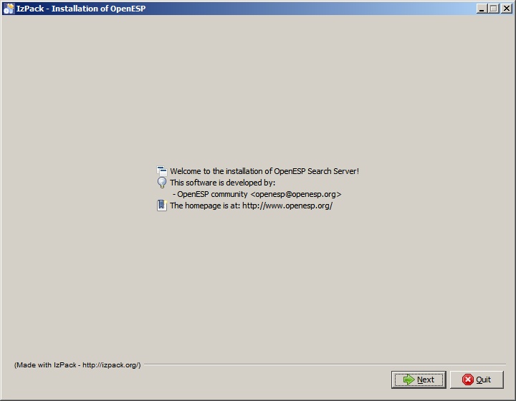
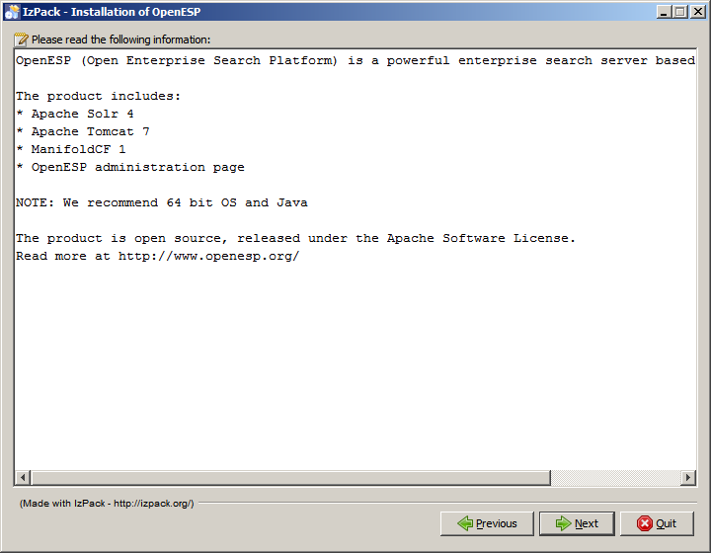
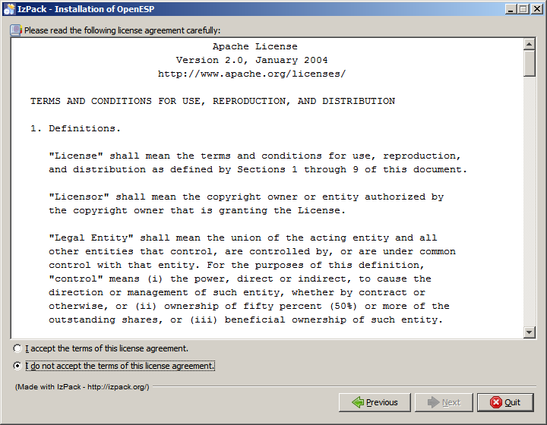
Choose what packages to install.
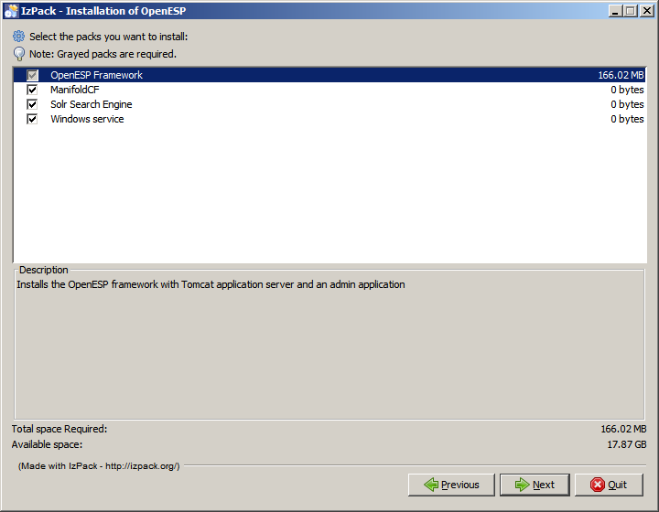

Choose your installation destination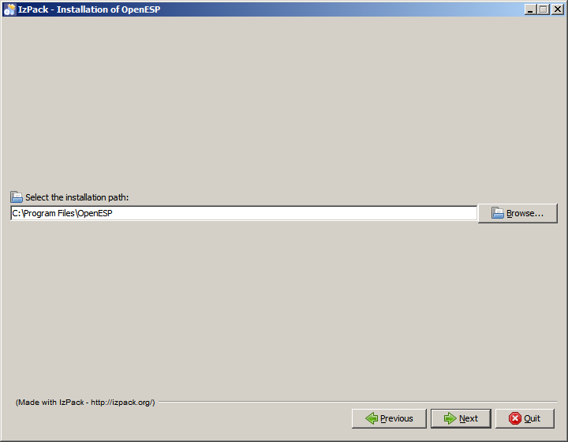
If your installer comes bundled with a custom Solr configuration zip, the installer can unpack that zip file and use it as its configuration. If a file called openesp-overlay.zip is found in the same directory as the installer, the installer will suggest it for you automatically. Default port is 18080 and default memory is 2048Mb.

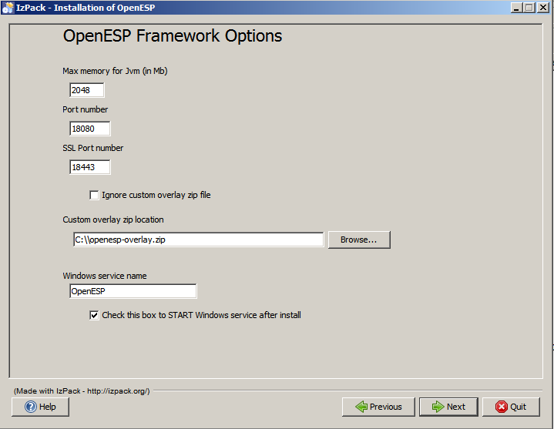
You can also apply a custom Solr Configuration from Zip file. If you selected to do so, choose where to find the zip file and where to unpack it. You may customize Solr HOME as well as where to put index and logs. The defaults should be good, but if your index is very large you may want to put it on a separate disk/partition.
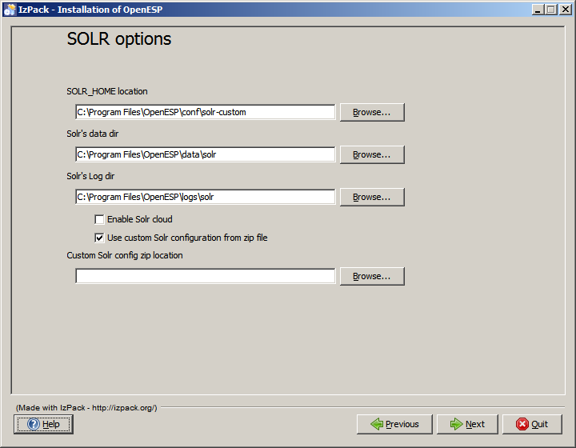
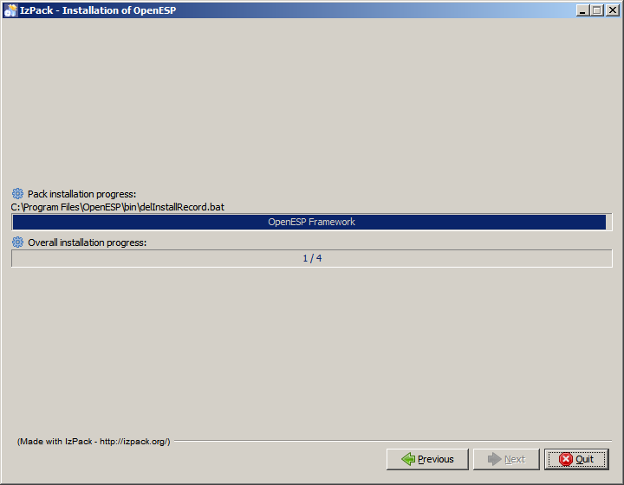
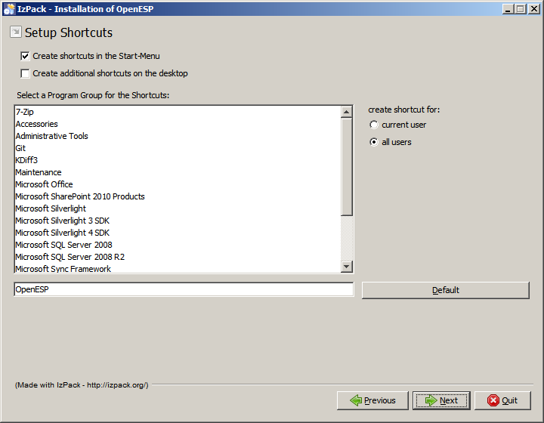
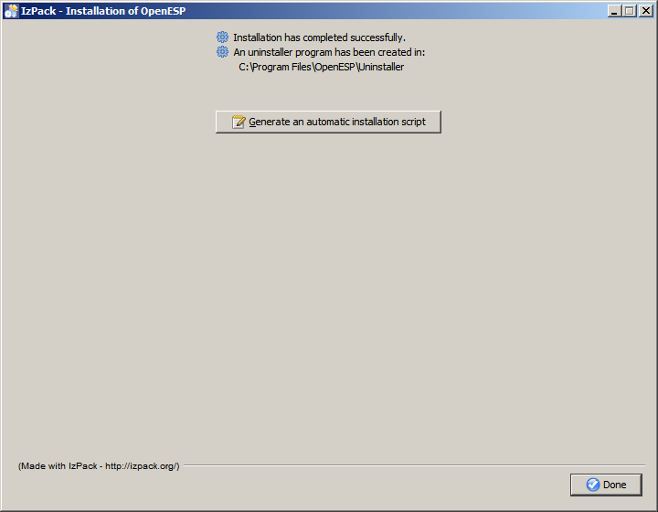

After successful installation, confirm the installation by opening http://localhost:18080/solr/ (replace localhost with your server's host name) in a browser.

Manual installation
If you want to to a manual install or automate the install using tools like Puppet (http://puppetlabs.com/) or Chef (http://www.opscode.com/chef/), follow this procedure. Although we use Unix syntax in this description, Windows users simply replace forward-slash with backslash and *.sh with *.bat
The procedure is simple:
- Obtain the ZIP deployment package (typically openesp-x.y.zip). After building openesp yourself from source, this resides in build/distributions/
- Un-zip the deployment package openesp-x.y.zip into a location of choice. We call this location OPENESP_HOME for convenience
- Note that ManifoldCF is disabled by default. To enable, open a command prompt, then CD to $OPENESP_HOME/bin/ and run ./openespctl enable mcf
- To start the server for local testing, CD to $OPENESP_HOME/bin/ then run ./run.sh or run.cmd
- To start the server in production, install a Windows service or Linux init script. This is currently only supported by installer. (In future there will be tool support through $OPENESP_HOME/bin/openespctl for this too.)
- To use a custom Solr configuration, edit the start script and modify the SOLR_HOME environment variable to point to your new solr-home
- To change memory settings, edit the start script and modify -Xms and -Xmx settings accordingly.
- To change port number, open $OPENESP_HOME/tomcat/conf/server.xml in an editor and change port number from 18080 to what you need.
- After successful installation, confirm the installation by opening http://localhost:18080/solr/ (replace localhost with your server's host name) in a browser.

Configuration
This chapter lists some common configuration options after install of the product. There is a command-line tool to help with many common tasks, and it is located in bin/openespctl

General

Ports
OpenESP uses Apache Tomcat as the Java Servlet container. During install the port number is set in $OPENESP_HOME/tomcat/conf/server.xml. You may change that to have OpenESP listen on another port.
bin/openespctl port <new port number> [<new ssl port number>]
Example: To change to port 8983 after install
bin/openespctl port 8983

Enable or disable apps
bin/openespctl <enable|disable> <app>
Example: to enable ManifoldCF (it is disabled by default), run
bin/openespctl enable mcf

Windows service startup options
When run as a Windows service, startup options such as memory, SOLR_HOME, logging options, which user to run the service as etc are registered in the service daemon program. To view/change these settings, you double click %OPENESP_HOME%\bin\OpenESPw.exe, or:
- Open a shell/command window with Administrator rights
[Windows+R] enter “cmd.exe”, then hit [SHIFT+CTRL+ENTER] to start as admin
- CD %OPENESP_HOME%\bin\
- OpenESPw.exe
- Do the needed changes

Securing the search server
Sometimes you want to secure the communication with Tomcat/Solr so that unauthorized people cannot access the search index. There are several ways to do that. The easiest is to block OpenESP/Tomcat's port (18080) in the server's firewall, so that traffic is only allowed from certain IP addresses or only from localhost.
Another way is to enable encrypted communication through SSL in Tomcat and only listen on the secure port using server certificates. OpenESP ships with SSL port enabled at port 18443, setup with client and server certificates, already setup in Tomcat. You'll find the certificates in $OPENESP_HOME/tomcat/conf/ssl/ folder.
To access the secure port from a browser, you'll need to import the CA certificate ca.pem and the browser certificate browser-client.pfx into your browser.
To re-generate your own certificates, run the script gen-certs.sh
TIP: To block access to insecure port 18080, edit $OPENESP_HOME/tomcat/conf/server.xml

Solr
Solr's configuration resides in $OPENESP_HOME/config/solr. After changing, reload the core to pick up changes. This can be done in Solr's administration panel:
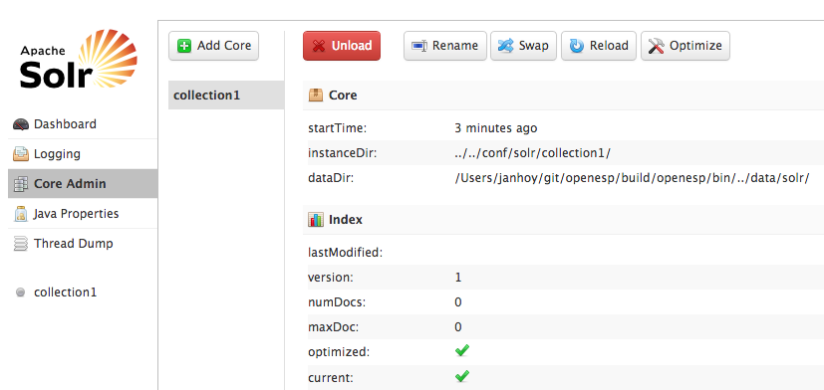
For Solr configuration options, plese refer to the Solr Wiki: http://wiki.apache.org/solr/

ManifoldCF
If you want to push configurations to ManifoldCF the mcf-api-service is the usual endpoint. Since OpenESP uses the “combined” war (http://manifoldcf.apache.org/release/release-1.2/en_US/how-to-build-and-deploy.html#Single-process+deployable+war) the API will be available at http://localhost:18080/mcf/api/.

Monitoring
We make it easy to setup Sematext SPM with OpenESP. On the welcome screen when you start OpenESP you'll find instructions for how to sign up and download SPM.
Once installed, simply run the command:
bin/openespctl spm install
This will enable monitoring by including the necessary startup options with your OpenESP service/daemon. Within a few minutes you'll be seeing a dashboard like the one below with full overview of key metrics for your search cluster, including alerts when something is wrong.

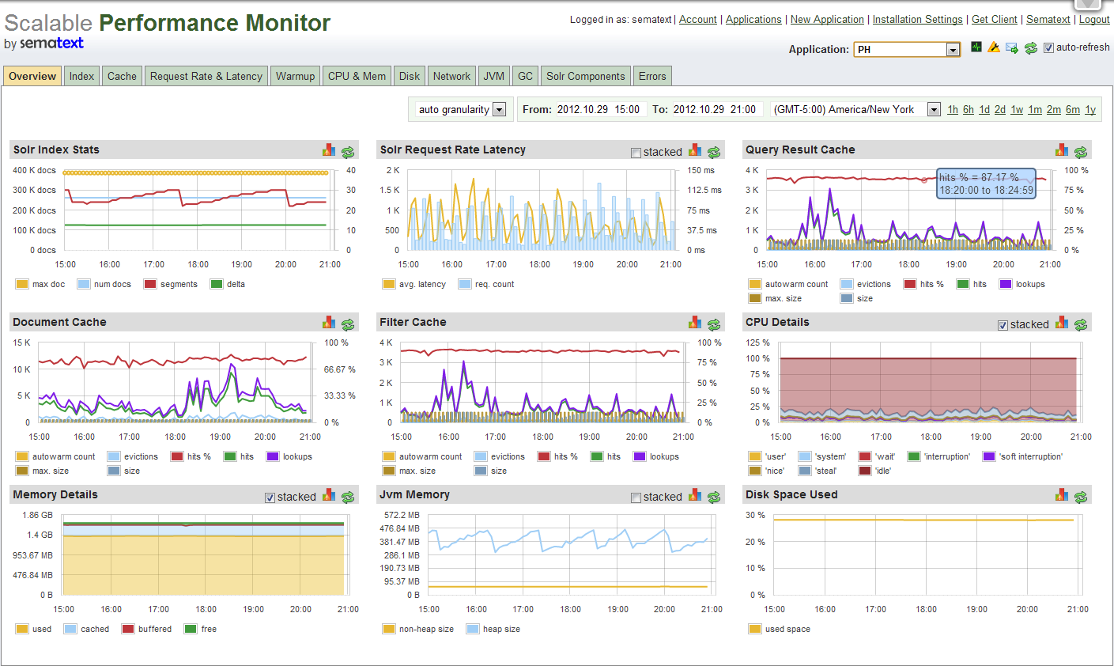
Search Analytics
OpenESP comes pre-bundled with cloud based search analytics integration. It is free to use after you register an account, and gives you deep insight into wow your end users interact with your service, i.e. top searches, identify slow queries and find queries that needs to be tuned because people do not click the top search results. Search Analytics is for your search service what Google Analytics is for your web site.
